Connie Lance
connie.lance@aims.edu
Excel Training - intermediate
Vestas Windsor
Aims Community College
Center for Workforce Development
and Innovation

Excel Intermediate Topics
Vestas Objectives | Expanded Performance Objectives
Planning a Workbook | Necessary data and form of the workbook
Hyperlinks | Insert, modify, and remove hyperlinks
Range Names | Create a Name Range  Use a range in a formula
Decision Making | Using Goal Seek
Data Validation | Restrict data entry by creating validation criteria  Use the Circle Invalid Data feature
Importing and Exporting Data | Get & Transform
Tables | Convert data into tables
Filters and AutoFilters | Filter a worksheet using a custom AutoFilter  Filter and sort a worksheet using conditional formatting or cell attributes
Working with Data | Get & Transform and Query Editor
Advanced data tools in Excel | Data Model and Power Pivot
Outlining | Convert a table to a normal range  Create subtotals in groups of related data
External References | Create formulas that link to cells in other worksheets or workbooks  Edit a link to a source workbook  Summarize data by creating formulas with range names that reference cells in other worksheets  Break a link to an external reference
Charts | Create a chart  Size, move, edit, format and delete a chart  Print a chart  Change a chart location
Protection | Protect cells within a workbook to prevent changes  Protect and unprotect the structure of a workbook  Require a password to open a workbook
Shared Workbooks | Share a workbook with other people and view other users who have the shared open at the same time  Edit a shared workbook and resolve conflicts with changes  Print a history of changes made to a shared workbook  Stop sharing a workbook  Save and share a workbook via email
Track Changes | Track changes made by individuals who share a workbook  Review and accept or reject tracked changes
Custom Views | Create and apply Custom Views
Under-Utilized Features | Text to speech  Customize the display options for Excel  Create and use templates

Planning a Workbook
When planning a workbook, there are several factors to keep in mind:
- What problems do I want to solve? Identify the goal or purpose of the workbook. Do you want to document expenses, manage inventory, determine costs, or something else?
- What data do I need? Determine the data, and the type of data, that you need for the workbook.
- What calculations do I need? There are many possible formulas you can use on that data.
- What form should my solution take? Do you want everything in a single worksheet? Does it need to print clearly? What formatting and colors will you use?
- 20 principles of Good Spreadsheet Practice 2018.pdf

Hyperlinks
You can link to a Web Page, a place in the workbook, a new workbook, or an email address. You can also use a graphic as a link. To modify a hyperlink, right-click on in and choose Edit Hyperlink.
You can delete a link by right-clicking and choosing Remove Hyperlink. This removes the link, but does not delete the text in the cell.
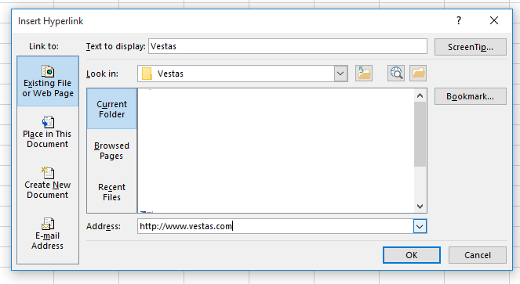
Insert Hyperlink
- Click Insert tab
- Click Hyperlink button in the Links group
- Make desired changes in dialog box
- Click OK
01RangeNames.xlsx
Create a link to Vestas.com.

Range Names
Range names can refer to a single cell, or a range of cells. Using range names in formulas makes it easier to understand the formula. Range names are more intuitive, more accurate, easier to remember, they do not change, and they make navigation easier. Cell references in range names are absolute references.
Create a Range Name
- Select cell(s)
- Click in Name box
- Type desired range name
- Press Enter
Delete a Range Name
- Click Formulas tab
- Click Name Manager button
- Click desired range name
- Click Delete button
- Click OK
- Click Close
Edit a Range Name
- Click Formulas tab
- Click Name Manager button
- Click desired range name
- Click Edit button
- Type new range name in Range text box
- Click OK
- Click Close

Use a range in a formula
01RangeNames.xlsx
Name the range H4:H24. Call it ClaimEst. Then create a function in H25 that will calculate the average of the claim estimates.

Decision Making
There are many ways to use data to make decisions. One of them is Goal Seek. The Goal Seek feature returns a value in a cell based on a target value you specify for another cell. The two cells must have a dependent relationship for Excel to calculate a value. With Goal Seek, you specify the final value, and Excel calculates in reverse to get it.
Goal Seek steps
- Make desired cell active
- Click Data tab
- Click What-If Analysis button
- Click Goal Seek
- Enter desired cell address in Set Cell text box (the final desired result)
- Enter desired target value in To Value text box (the formula to get there)
- Enter dependent cell address in By Changing Cell text box (what will change)
- Click OK
- Click OK or Cancel
02GoalSeek.xlsx
In the example, set cell B11 to 76 by changing B9. The result shows that the student will need to get 81.5 on the final to get 76% overall.
03GoalSeek.xlsx
Change the balance on the January sheet to 3,000 by changing the second deposit.

Data Validation
Data can be validated as it is being entered in to a worksheet, and invalid data can be prevented from being stored. Or, a warning can show to state that data has been entered that does not conform to the restrictions.
You can allow data based on values, dates, times, and text lengths. or restrict entries to the values in a drop-down list. You can specify the input Message, which tells the user what data is acceptable. You can specify the Error Alert, the warning message when invalid data is entered.
Create a Data Validation Rule:
- Select desired range
- Click Data tab
- Click Data Validation button
- Specify validation criteria in Settings tab
- Click Input Message tab
- Type input message title and text
- Click Error Alert tab
- Select error style (Stop, Warning, or Information)
- Type error alert title and message text
- Click OK
In the Settings tab, you can choose List and in-cell dropdown checkbox. Add the list of allowed items in the Source text box, separated by commas.
04DataValidation.xlsx
In the example, be sure only valid dates can be entered. Then, use a drop-down list for valid names.

Circle Invalid Data Feature
If a range of cells was created before a validation rule was created, you can circle the invalid data so you can go back and check it.
- Click Data tab
- Click Data Validation button
- Click on Circle Invalid Data
When you are finished, repeat steps 1 and 2, then click on Clear Validation Circles
Show the invalid data that was entered earlier.

Tables
With a Table, we can easily perform the following data processing tasks:
- Remove Duplicate Records
- Filter the data in the Table to show only relevant items
- Sort the data
Structured references can be made up of several parts:
- The name of the table
- The name of the column in square brackets
- An @ sign if you wish to refer to a value in the same row as the formula
- [#Headers] or [#Totals] to refer to a column name or to a value on a totals row
For example, =TableName[@[ColumnName]] would refer to the same row in a column named ColumnName from a Table named TableName
05Manage.csv

Get & Transform
Get & Transform provides fast, easy data gathering and shaping capabilities. Get & Transform enables you to connect, combine, and refine data sources to meet your analysis needs. You can import large volumes of data from multiple sources.

Access Get & Transform on the Data tab → Get & Transform group, where you can choose to get data from many different sources (for example, to query a Table choose From Table)
06Data.xlsx
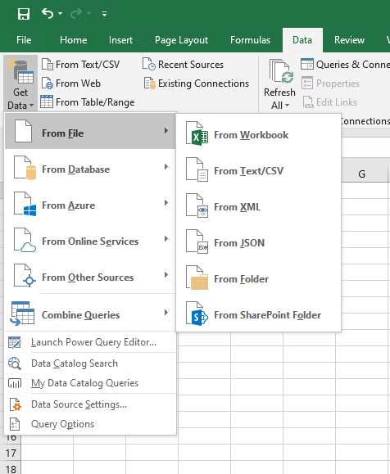
Once you have selected the source of your data, the Query Editor will open and you can begin transforming the data to clean it up.
Transformations can be any of the following and much more:
- Removing duplicates
- Creating new columns, or removing existing columns
- Split a column into component parts (for example, split a date into its parts)
- Replace values
The steps are recorded, so you can back up to a previous point in your work.
After transforming the data, you will load it into a Table on your worksheet, or create a connection in memory (this is known as the Data Model).

Query Editor
With Query Editor, you can navigate, define, and perform data transform operations over a data source. To display the Query Editor dialog box, connect to a data source, and click Edit Query in the Navigator pane or double-click a query in the Workbook Queries pane.
The Query Editor includes these features:
- Query Editor ribbon.
- Navigator pane that enables you to browse structured data sources to find the data table that you want to query.
- Context menus are specific to an element within the editor preview grid—such as a table column.
- Preview grid that displays a preview of data from the results of each query step. You interact within the Preview pane to shape data and rearrange tables into a subject table to match your data analysis requirements.
- The Query Settings panel, which includes each query step. A step corresponds to each of the data acquisition or data transformation tasks that can be applied on a query. You can backtrack these steps
.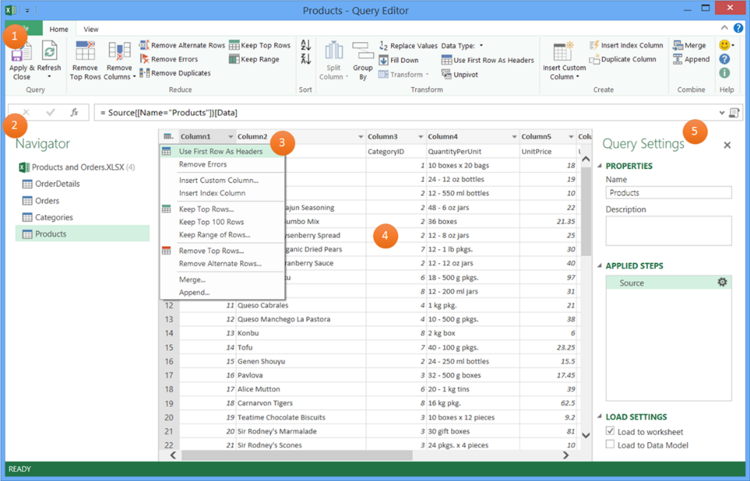

Data Model
Excel has some very powerful replacements for the Report Manager, which is no longer supported in Excel.
Create a Data Model in Excel
A Data Model allows you to integrate data from multiple tables, effectively building a relational data source inside an Excel workbook. Within Excel, Data Models are used transparently, providing tabular data used in PivotTables and PivotCharts. A Data Model is visualized as a collection of tables in a Field List, and most of the time, you’ll never even know it's there.
07Data.xlsx
Before you can start working with the Data Model, you need to get some data. For that we'll use the Get & Transform.
- In Excel 2016, and Excel for Microsoft 365, use Data > Get & Transform Data > Get Data to import data from any number of external data sources, such as a text file, Excel workbook, website, Microsoft Access, SQL Server, or another relational database that contains multiple related tables.
- Excel prompts you to select a table. If you want to get multiple tables from the same data source, check the Enable selection of multiple tables option. When you select multiple tables, Excel automatically creates a Data Model for you.
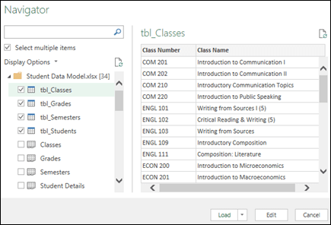
- Select one or more tables, then click Load.
If you need to edit the source data, you can choose the Edit option and use the Query Editor.
You now have a Data Model that contains all of the tables you imported, and they will be displayed in the PivotTable Field List.
- Models are created implicitly when you import two or more tables simultaneously in Excel.
- Models are created explicitly when you use the Power Pivot add-in to import data. In the add-in, the model is represented in a tabbed layout similar to Excel, where each tab contains tabular data.

Power Pivot
Visually explore your data with a variety of customizable reports. Create visualizations by dragging and dropping the fields you want to view. Choose from a variety of charts and graphs to tell your data's story. Power Pivot allows you to perform powerful data analysis and create sophisticated data models. With Power Pivot, you can mash up large volumes of data from various sources, perform information analysis rapidly, and share insights easily. You can use the Data Model and a collection of tables to create relationships stored as part of the workbook. The Data Model integrates deeply with other features in Excel, such as tables and Pivot Tables, to provide a seamless analytics experience.
- A model can contain a single table. To create a model based on just one table, select the table and click Add to Data Model in Power Pivot. You might do this if you want to use Power Pivot features, such as filtered datasets, calculated columns, calculated fields, KPIs, and hierarchies.
- Table relationships can be created automatically if you import related tables that have primary and foreign key relationships. Excel can usually use the imported relationship information as the basis for table relationships in the Data Model.
- There are ways to reduce the size of a data model
- Tip: How can you tell if your workbook has a Data Model? Go to Power Pivot > Manage. If you see worksheet-like data, then a model exists.

Create Relationships between your tables
The next step is to create relationships between your tables, so you can pull data from any of them. Each table needs to have a primary key, or unique field identifier, like Student ID, or Class number. The easiest way is to drag and drop those fields to connect them in Power Pivot's Diagram View.
- Go to Power Pivot > Manage.
- On the Home tab, select Diagram View.
- All of your imported tables will be displayed, and you might want to take some time to resize them depending on how many fields each one has.
- Next, drag the primary key field from one table to the next. The following example is the Diagram View of our student tables:
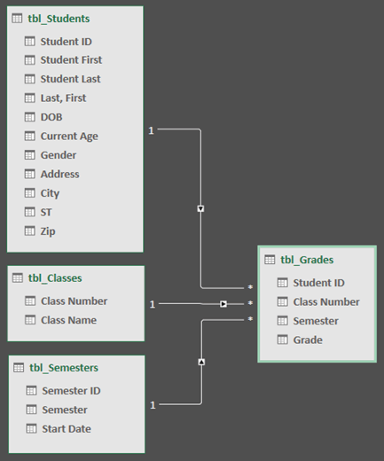
We've created the following links:
tbl_Students | Student ID > tbl_Grades | Student ID
In other words, drag the Student ID field from the Students table to the Student ID field in the Grades table.
tbl_Semesters | Semester ID > tbl_Grades | Semester
tbl_Classes | Class Number > tbl_Grades | Class Number
Notes on PivotTables:
- Field names don't need to be the same in order to create a relationship, but they do need to be the same data type.
- The connectors in the Diagram View have a "1" on one side, and an "*" on the other. This means that there is a one-to-many relationship between the tables, and that determines how the data is used in your PivotTables.
- The connectors only indicate that there is a relationship between tables. They won't actually show you which fields are linked to each other. To see the links, go to Power Pivot > Manage > Design > Relationships > Manage Relationships. In Excel, you can go to Data > Relationships.

Use a Data Model to create a PivotTable or PivotChart
An Excel workbook can contain only one Data Model, but that model contains multiple tables which can be used repeatedly throughout the workbook. You can add more tables to an existing Data Model at any time.
- In Power Pivot, go to Manage.
- On the Home tab, select PivotTable.
- Select where you want the PivotTable to be placed: a new worksheet, or the current location.
- Click OK, and Excel will add an empty PivotTable with the Field List pane displayed on the right.
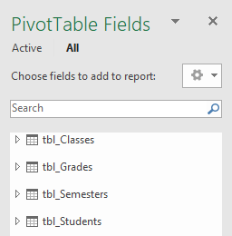
Next, create a PivotTable, or create a Pivot Chart. If you've already created relationships between the tables, you can use any of their fields in the PivotTable. We've already created relationships in the Student Data Model sample workbook.

Add existing, unrelated data to a Data Model
Suppose you’ve imported or copied lots of data that you want to use in a model, but haven't added it to the Data Model. Pushing new data into a model is easier than you think.
- Start by selecting any cell within the data that you want to add to the model. It can be any range of data, but data formatted as an Excel table is best.
- Use one of these approaches to add your data:
- Click Power Pivot > Add to Data Model.
- Click Insert > PivotTable, and then check Add this data to the Data Model in the Create PivotTable dialog box.
The range or table is now added to the model as a linked table.

Adding data to a Power Pivot table
In Power Pivot, you cannot add a row to a table by directly typing in a new row like you can in an Excel worksheet. But you can add rows by copying and pasting, or updating the source data and refreshing the Power Pivot model.

Power BI
Power BI lets you centralize your data, simplify it with queries you create, and share it in highly visual reports. It is a suite of business analytics tools that deliver insights throughout your organization. With Power BI Desktop, you can connect to hundreds of data sources, simplify data prep, and drive ad hoc analysis. You can also produce reports and then publish them for your organization to on the web and across mobile devices. Security tools are built-in.

Filters
Filter a worksheet using a custom AutoFilter
- Select range
- Click Sort & Filter button
- Click Filter
- Deselect range
- Click filter arrow at top of desired column
- Point to Number Filters
- Click desired filter category
- Enter criteria at Custom AutoFilter dialog box
- Click OK
Notice that the data is not deleted. You can tell by the row numbers that some rows are skipped. You can filter by more than one criterion.
08Filters.xlsx
Select A3:I20. Add filters and experiment using different filters.

Filter and sort a worksheet using conditional formatting or cell attributes
- Select range
- Click Sort & Filter button
- Click Filter
- Deselect range
- Click filter arrow at top of desired column
- Point to Filter by Color or Sort by Color
- Click desired color or icon
OR
- Rick-click cell with desired color or icon
- Point to Filter or Sort
- Click desire filter or sort option
08Filters.xlsx
Add a conditional formatting icon set to one of the fields. Filter by one of those icons.

Outlining
A table can be converted to a range. You need to convert it before you can use the subtotal feature.
09Outline.xlsx
Convert a table to a normal range
- Make a table cell active
- Click Table Tools Design tab
- Click Convert to Range button
- Click Yes
Create subtotals in groups of related data
- Select range
- Click Data tab
- Click Subtotals button
- Select field to group by in At each change in option box
- Select desired function in Use function option box
- Select field(s) to subtotal in Add subtotal to list box
- Click OK
- Deselect range

Group Data by Rows
- Select range to be grouped within outlined worksheet
- Click Data tab
- Click Group button
- Click OK

Ungroup Data by Rows
- Select grouped range within outlined worksheet
- Click Data tab
- Click Ungroup button
- Click OK
Although less common, columns can be grouped and ungrouped.

External References
You can move, link, copy, and/or paste date between worksheets. Original data is in source worksheet, the link is in the dependent worksheet
Link Data between worksheets
- Select cells
- Click Copy button
- Click desired worksheet tab
- Click in desired cell
- Click Paste button
- Click Paste Link in the drop-down list
After pasting data, note the cell reference includes the sheet name (='1st Qtr'!C4)
10LinkSheets.xlsx
Copy the Budget data in the 1st Quarter sheet, and copy it to each of the other sheets by creating a link.

Original data is in source workbook, the link is in the destination workbook.
Link to cells in other worksheets or workbooks
Create a Link to an External Reference
- Open source workbook
- Open destination workbook
- Arrange windows as desired
- Make formula cell active in destination workbook
- Type =
- Click to activate source workbook
- Click source cell
- Press Enter
Point and click results in an absolute reference to the source workbook
Edit a link to a source workbook
Close the destination, change the source and close it, then reopen the destination.
You will get a Security Warning: Automatic update of links has been disabled – Enable Content
Summarize data by creating formulas with range names that reference cells in other worksheets
Sum Multiple Worksheets Using Range Names
- Make formula cell active
- Type =sum(
- Type first range name
- Type a comma
- Type second range name
- Type a comma
- Continue typing range names separated by commas until finished
- Type )
- Press Enter
11LinkSheets.xlsx
Range names have already been created. Use them to summarize in the AttendanceSummary sheet.
12LinkBooks.xlsx
Add a line in 11LinkSheets.xlsx for the attendance for commercial vehicles. Link to the data from 12LinkBooks.xlsx

Break a link to an external reference
Data tab, Connections group, Edit Links
Choose a link, then click Break Link on the right

Charts
A chart is a visual representation of data. By default, a chart is inserted in the same worksheet as the selected cells. A chart is linked to the data used to create it. When a chart is selected, you can use the buttons on the right to edit it (Chart Elements, Chart Styles, and Chart Filters).
Create a chart
- Select cells
- Click Insert tab
- Click desired chart button
- Click desired chart style in drop-down list
Create a recommended chart
- Select cells
- Click Insert tab
- Click Recommended Charts button
- Click OK at Insert Chart dialog box
Size, move, edit, format and delete a chart
Size: Use the circular sizing handles on the chart borders
Move: Select the chart, then position the mouse so you see the four-headed arrow, click and drag
Edit: Select the chart, then reselect the data range that is highlighted
Format: Select the Chart Styles button at upper right, or use Format Chart pane on the right
Delete: Select the chart and press the Delete key
Delete a chart element: Select the element and press the Delete key
Print a chart
- Select chart
- Click File tab
- Choose Print
- Choose Print Selected Chart under Settings
Change the Chart Style
- Make chart active
- Click Chart Tools Design tab
- Click Change Chart Type button
- Click desired chart type
- Click desired chart style
- Click OK
Change a chart location
- Make chart active
- Click Chart Tools Design tab
- Click Move Chart button
- Click New Sheet option
- Click OK
13SalesChart.xlsx
Create a bar chart. Add a total in row 5 and create a pie chart.

Protection
You can protect an entire worksheet to prevent another person from accidentally inserting or deleting or otherwise changing data that you do not want modified. If you add a password, you absolutely must remember it. Excel will warn you that if you lose or forget the password, it cannot be recovered.
Protect a worksheet
- Open workbook
- Activate desired sheet
- Click Review tab
- Click Protect Sheet button
- Type password
- Choose allowable actions
- Click OK
- Retype password
- Click OK
If a worksheet is protected, no one can insert, delete, or modify any cells.
Each cell in a workbook has a lock attribute that activates when the worksheet is protected. To allow individual cells in a worksheet to be editable, select the cells and turn off the lock attribute before protecting the workbook. Locking cells does not affect them until you protect the worksheet.
Protect cells within a workbook to prevent changes
- Clear the lock attribute on those cells you want to be able to change
  - Select the cells
  - Click the Home tab
  - Click the Format button in the Cells group
  - Clear the Lock Cell check box in the Protection section
- Protect the worksheet
  - Click Review tab
  - Click Protect Sheet button
Unlock a cell
- Select cell(s) to be unlocked
- Click Home tab
- Click Format button
- Click Lock Cell
- Deselect cell(s)

Protect and unprotect the structure of a workbook
If the structure is protected, you cannot insert or delete a sheet, or unhide a hidden sheet.
- Open workbook
- Click Review tab
- Click Protect Workbook button
- Type password if desired
- Click OK
- Retype password (if entered in Step 4)
- Click OK
To unprotect:
- Click Review tab
- Click Protect Workbook button
- If the workbook was password-protected, enter the password
- Click OK
Require a password to open a workbook
You can prevent unauthorized access to an Excel workbook by adding an encrypted password to open and/or modify the workbook.
- Open workbook
- Click File tab
- Click Protect Workbook button
- Click Encrypt with Password
- Type password
- Press Enter or click OK
- Retype password
- Press Enter or click OK
To unprotect:
- Click File tab
- Click Protect Workbook button
- Click Encrypt with Password
- Delete the password
- Click OK
14Protection.xlsx
In the example, protect the first worksheet, unlock some cells in the other worksheet and protect the rest, protect the workbook structure, and protect the workbook with a password.

Shared Workbooks
15Share.xlsx
A shared workbook is saved to a network folder that is accessible to other people. Excel tracks each person’s changes and displays a prompt if two people have the file open at the same time and try to change the same data.
Share a Workbook with Other People
- Open the workbook
- Click the Review tab
- Click Share Workbook button
- Click Allow changes by more than one user at the same time check box
- Click OK to close Share Workbook dialog box
- Click OK to continue
Notice that Excel adds [Shared] to the Title bar next to the name of the file.

View Other Users Who Have The Shared Open At The Same Time
- Open the workbook
- Click the Review tab
- Click Share Workbook button
- Review names in Who has this workbook open now list box
- Click OK

You can edit a shared workbook and resolve conflicts with changes
Resolving Conflicts in a Shared Workbook
- Open shared workbook
- Make desired edits
- Click Save button
- Click Accept Mine or Accept Other button for each conflict
- Click OK

Change the status of shared workbook to exclusive to prevent further changes. However, this prevents anyone currently using the workbook from saving their changes, and it erases the history of changes. Print a History sheet before changing the status to exclusive.
Print a history of changes made to a shared workbook
- Open share workbook
- Click the Review tab
- Click Track Changes button
- Click Highlight Changes
- Change When to All
- If necessary, clear the Who box
- If necessary, clear the Where box
- Click List changes on a new sheet check box
- Click OK

The history sheet will be removed when the share workbook is saved. You should Print the history sheet, or save it in a new workbook file. Once you have the list of changes, you can change the status to exclusive.
Stop Sharing a Workbook
- Open the workbook
- Click the Review tab
- Click Share Workbook button
- Remove check mark from Allow changes from more than one user at the same time check box
- Click OK
- Click Yes when you are warned that the history will be erased.

You could also send a workbook via email within Excel. This assumes that you are using Microsoft Outlook for email.
Save and share a workbook via email
- Open the workbook
- Click the File tab
- Click Share
- Click Email
- Click Send an Attachment button
- Type recipient’s email address in To text box
- If necessary, edit text in Subject text box
- Type message in message window
- Click Send

Track Changes
If you turn on Track Changes, Excel will automatically share the workbook. Then you can highlight the changes that have been made. It is more and more common to share files in OneDrive.
Track Changes
- Open workbook
- Click Review tab
- Click Track Changes button
- Click Highlight Changes
- Click Track Changes While Editing check box
- Click OK twice
Highlight Changes
- Open tracked workbook
- Click Review tab
- Click Track Changes button
- Click Highlight Changes
- Change When to “Not yet reviewed”
- Make sure Who is set to Everyone
- Click OK
When you hover the mouse over a highlighted cell, a pop-up box shows who changed the cell, along with the date, time, original entry and revised entry.
Each person’s changes can be designated with a different colored outline around the cell.
You can also list changes on a new sheet. Just uncheck boxes Who and Where in the Highlight Changes dialog, then check List changes in a new sheet.

You can accept or reject each change that has been made.
Accept and Reject Changes
- Open tracked workbook
- Click Review tab
- Click Track Changes button
- Click Accept/Reject Changes
- Make sure When is set to “Not yet reviewed”
- Make sure Who is set to Everyone
- Click OK
- Click Accept or Reject button at each change
Turn Off Track Changes
- Open tracked workbook
- Click Review tab
- Click Highlight Changes
- Click Track Changes While Editing check box to remove check mark
- Click OK
- Click Yes
16Track.xlsx
Use the example to turn on tracking, make some changes, and accept or reject the changes.

Custom Views
A Custom view saves display and print settings for the worksheet. Custom views cannot be used in a worksheet with a table. Custom views can only be used on the worksheet it was created for. Multiple custom views can be created for the same worksheet.
Create a Custom View
- Change display and print settings as desired
- Click View tab
- Click Custom Views
- Click Add
- Type name for new view
- Choose desired Include in view options
- Click OK
Apply a Custom View
- Click View tab
- Click Custom Views
- Click desired view name
- Click Show
17Views.xlsx
Create custom views that show only the daytime or nighttime events.

Under-Utilized Features
Tell Me feature
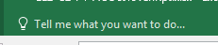
This works better for some tasks than others.
The F1 key opens Excel Help, which is quite extensive. The Tell Me feature goes directly to the menu that you searched for. Try searching for “Create Chart”.

Text to Speech
This is helpful when you need to double-check any data that has been entered.
Turn on Text to Speech
- Next to the Quick Access Toolbar, click Customize Quick Access Toolbar.
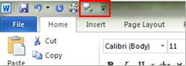
- Click More Commands.
- In the Choose commands from list, select All Commands.
- Scroll down to the Speak command, select it, and then click Add.
- Click OK.
- When you want to use the text-to-speech command, select some cells and click the icon on the Quick Access Toolbar.

Customize the display options for Excel
There are many different ways to display an Excel worksheet.
Change the display options
- Click the File tab
- Click Options
- Click Advanced in the left pane
- Change display options as desired
- Click OK
17Views.xlsx

Create and use templates
Create a file that you want to save as a template. When you save it, change the Save As type to Excel Template. If the file has macros, you will need to save it as a Macro-Enabled Template.
Use a Custom template
- Click File tab
- Click New
- Click PERSONAL
- Double-click the desired template
By default, template files are saved in the path C:\Users\Username\My Documents\Custom Office Templates
Template files have a file extension of xltx. Macro-enabled templates end in xltm. There are hundreds of templates available online.

Other Resources
https://exceljet.net/ | YouTube channel ExcelIsFun
https://www.mrexcel.com/ | https://www.lynda.com/Excel-tutorials/Excel-Scenario-Planning-Analysis/636107-2.html
https://www.edx.org/ | https://www.coursera.org/search?query=microsoft%20excel&

Notes
________________________________________________________________________________________________________________________________________________________________________________________________________________________________________________________________________________________________________________________________________________________________________________________________________________________________________________________________________________________________________________________________________________________________________________________________________________________________________________________________________________________________________________________________________________________________________________________________________________________________________________________________________________________________________________________________________________________________________________________________________________________________________________________________________________________________________________________________________________________________________________________________________________________________________________________________________________________________________________________________________________________________________________________________________________________________________________________________________________________________________________________________________________________________________________________________________________________________________________________________________________________________________________________________________________________________________________________________________________________________________________________________________________________________________________________________________________________________________________________________________________________________________________________________________________________________________________________________________________________________________________________________________________________________________________________________________________________________________________________________________________________________________________________________________________________________________________
____________________________________________________________________________________________________________________________________________________________________________________________________________________________________________________________________________________________________________________________________________________________________________________________________________________________________________________________________________________________________________________________________________________________________________________________________________________________________________________________________________________________________________________________________________________________________________________________________________________________________________________________________________________________________________________________________________________________________________________________________________________________________________________________________________________________________________________________________________________________________________________________________________________________________________________________________________________________________________________________________________________________________________________________________________________________________________________________________________________________________________________________________________________________________________________________________________________________________________________________________________________________________________________________________________________________________________________________________________________________________________________________________________________________________________________________________________________________________________________________________________________________________________________________________________________________________________________________________________________________________________________________________________________________________________________________________________________________________________________________________________________________________________________________________________________________________

